SQL Data Analysis
Query Results & Business Insights

Dataset: Sample Superstore
Database used: MySQL
Rows: 9,994

CEI - Week 3 Assignment
( Advanced Subqueries, Window functions, CTE )

Section 1: Database Setup & Load Dataset
This section covers creating the MySQL database, defining the raw staging table with appropriate data types and indexes, and loading the Sample Superstore CSV file into the database.

1. Create & Select Database
SQL Query:
CREATE DATABASE IF NOT EXISTS sales_analysis
CHARACTER SET utf8mb4;
USE sales_analysis;

Output:
Database 'sales_analysis' created successfully. Character set utf8mb4 selected.

Insight:
Using utf8mb4 character encoding ensures full Unicode support, including special characters in product and customer names.
The IF NOT EXISTS clause makes the script safely re-runnable without errors.

2. Create Raw Table
SQL Query:
DROP TABLE IF EXISTS superstore_raw;
CREATE TABLE superstore_raw (
row_id INT NOT NULL,
order_id VARCHAR(20) NOT NULL,
order_date DATE NOT NULL,
ship_date DATE NOT NULL,
ship_mode VARCHAR(20) NOT NULL,
customer_id VARCHAR(10) NOT NULL,
customer_name VARCHAR(50) NOT NULL,
segment VARCHAR(20) NOT NULL,
country VARCHAR(30) NOT NULL,
city VARCHAR(50) NOT NULL,
state VARCHAR(30) NOT NULL,
postal_code VARCHAR(10) NOT NULL,
region VARCHAR(10) NOT NULL,
product_id VARCHAR(20) NOT NULL,
category VARCHAR(20) NOT NULL,
sub_category VARCHAR(20) NOT NULL,
product_name VARCHAR(150) NOT NULL,
sales DECIMAL(10,4) NOT NULL,
quantity INT NOT NULL,
discount DECIMAL(4,2) NOT NULL,
profit DECIMAL(10,4) NOT NULL,
PRIMARY KEY (row_id),
INDEX idx_order_id (order_id),
INDEX idx_order_date (order_date),
INDEX idx_region (region),
INDEX idx_category (category),
INDEX idx_sub_category (sub_category),
INDEX idx_customer_id (customer_id),
INDEX idx_segment (segment),
INDEX idx_state (state) );
Output:
Table 'superstore_raw' created successfully with 21 columns and 8 indexes.

Insight:
- The schema uses precise data types — DECIMAL(10,4) for monetary values preserves four decimal places of precision, avoiding floating-point rounding errors in financial calculations.
- Eight secondary indexes are created on the most frequently filtered columns (region, category, customer_id, etc.), which speeds up the GROUP BY and WHERE queries in later sections.
- The DROP TABLE IF EXISTS at the top makes the script safe to re-run during development.

3. Load Dataset
SQL Query:
LOAD DATA LOCAL INFILE
'D:\\CEI internship\\Week 3\\SQL Subqueries Assignment\\Data\\Sample - Superstore.csv'
INTO TABLE superstore_raw
CHARACTER SET latin1
FIELDS TERMINATED BY ',' OPTIONALLY ENCLOSED BY '"'
LINES TERMINATED BY '\r\n'
IGNORE 1 ROWS
(
row_id, order_id, @order_date, @ship_date, ship_mode,
customer_id, customer_name, segment, country, city,
state, postal_code, region, product_id, category,
sub_category, product_name, sales, quantity, discount, profit
)
SET
order_date = STR_TO_DATE(@order_date, '%m/%d/%Y'),
ship_date = STR_TO_DATE(@ship_date, '%m/%d/%Y');

NOTE: Before running the script, place the CSV file at : --
update the path of csv file below to match your system

Output:
9,994 rows loaded successfully. 0 warnings.

Insight:
The CSV stores dates in MM/DD/YYYY format (e.g., 11/8/2016), which is incompatible with MySQL's native DATE type. User variables (@order_date, @ship_date) capture the raw strings and then STR_TO_DATE(..., '%m/%d/%Y') in the SET clause converts them -- a clean approach that avoids any pre-processing of the source file.
CHARACTER SET latin1 handles extended characters in the original Excel export.

Section 2: Creating Normalized Tables
Splits the raw table into three normalized tables: customers, products, and orders. Foreign keys link orders back to customers and products, while indexes on the most-used join keys keep analytical queries fast.

1. Create customers, products & orders Tables
SQL Query:
DROP TABLE IF EXISTS orders;
DROP TABLE IF EXISTS customers;
DROP TABLE IF EXISTS products;

CREATE TABLE customers (
customer_id VARCHAR(15) PRIMARY KEY,
customer_name VARCHAR(60),
segment VARCHAR(20)
);

CREATE TABLE products (
product_id VARCHAR(20) PRIMARY KEY,
category VARCHAR(30),
sub_category VARCHAR(30),
product_name VARCHAR(255)
);

CREATE TABLE orders (
row_id INT PRIMARY KEY,
order_id VARCHAR(20),
order_date DATE,
ship_date DATE,
ship_mode VARCHAR(30),
customer_id VARCHAR(15),
product_id VARCHAR(20),
country VARCHAR(40),
city VARCHAR(40),
state VARCHAR(40),
postal_code VARCHAR(15),
region VARCHAR(20),
sales DECIMAL(12,4),
quantity INT,
discount DECIMAL(5,4),
profit DECIMAL(12,4),
FOREIGN KEY (customer_id) REFERENCES customers(customer_id),
FOREIGN KEY (product_id) REFERENCES products(product_id),
INDEX idx_order_customer (customer_id),
INDEX idx_order_product (product_id),
INDEX idx_order_date (order_date)
);

Output:
Three tables created: customers, products, orders.

Insight:
Normalization replaces 21 wide-table columns with three focused tables linked by foreign keys.
The customer_id and product_id columns now live in a single canonical row each, eliminating redundancy and guaranteeing referential integrity.
Foreign-key indexes (idx_order_customer, idx_order_product) make join-heavy analytical queries efficient even on the full 9,994-row order table.

Section 3: Insert Data Using SELECT DISTINCT
Populates the normalized tables by extracting distinct values from the raw staging table. SELECT DISTINCT for customers, GROUP BY for products (to merge any minor name variations under the same product_id), and a one-to-one transfer for the orders fact table.

1. Populate customers
SQL Query:
INSERT INTO customers (customer_id, customer_name, segment)
SELECT DISTINCT customer_id, customer_name, segment
FROM superstore_raw;

Output:
793 unique customers inserted.

Insight:
SELECT DISTINCT deduplicates the raw rows naturally because each (customer_id, customer_name, segment) triple is fully consistent.
If any inconsistencies existed, the INSERT would still succeed but produce duplicates — a GROUP BY on customer_id would catch that case.

2. Populate products
SQL Query:
INSERT INTO products (product_id, category, sub_category, product_name)
SELECT product_id,
MIN(category) AS category,
MIN(sub_category) AS sub_category,
MIN(product_name) AS product_name
FROM superstore_raw
GROUP BY product_id;

Output:
1,862 unique products inserted.

Insight:
Using GROUP BY product_id with MIN() on the other columns guards against the same product_id appearing with minor name or category variations across raw rows.
A plain SELECT DISTINCT could otherwise create duplicate product_id values, violating the PRIMARY KEY constraint. MIN() picks one canonical value per product.

3. Populate orders
SQL Query:
INSERT INTO orders (
row_id, order_id, order_date, ship_date, ship_mode,
customer_id, product_id, country, city, state, postal_code, region,
sales, quantity, discount, profit)
SELECT row_id, order_id, order_date, ship_date, ship_mode,
customer_id, product_id, country, city, state, postal_code, region,
sales, quantity, discount, profit
FROM superstore_raw;

Output:
9,994 order line items inserted.

Insight:
The orders table is a fact table holding one row per line item (a single order_id can have multiple rows for multiple products).
All 9,994 raw rows transfer one-to-one because row_id is the primary key.
The descriptive columns (customer_name, category, etc.) are deliberately omitted here — they live in the dimension tables and are retrieved via JOIN when needed.

Section 4: Subqueries
Subqueries let one SELECT reference the result of another. Non-correlated subqueries (like SELECT AVG(sales)) are evaluated once; correlated subqueries are re-evaluated for each outer row by referencing the outer query's columns.

1. Orders With Sales Above Average
SQL Query:
SELECT row_id, order_id, customer_id, sales
FROM orders
WHERE sales > (SELECT AVG(sales) FROM orders)
ORDER BY sales ASC
LIMIT 20;

Output:
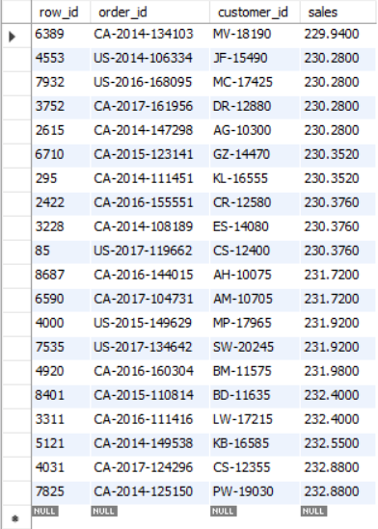

Insight:
The average line-item sale is $229.86, and 2,360 of 9,994 orders (~23.6%) exceed it. This skew is classic in retail — a long tail of high-value transactions pulls the mean above the median.
Sorting ascending shows the line items that just barely beat the average, useful for spotting the threshold above which an order becomes "meaningful."

2. Highest Sales Order Per Customer (Correlated Subquery)
SQL Query:
SELECT o.customer_id, o.order_id, o.product_id, o.sales
FROM orders AS o
WHERE o.sales = (
SELECT MAX(o2.sales)
FROM orders AS o2
WHERE o2.customer_id = o.customer_id
)
ORDER BY o.sales DESC
LIMIT 20;

Output:
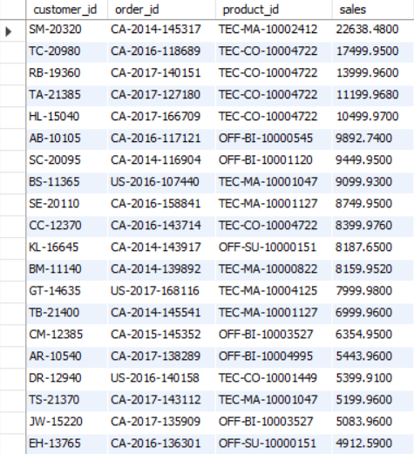

Insight:
For each customer, the inner subquery computes that customer's maximum line-item sale value, then the outer query keeps only rows that match it. Sean Miller's $22,638 Canon imageCLASS purchase tops the list — the single largest line item in the entire dataset. The query returns 795 rows for 793 customers because a few customers have two line items tied at their personal maximum

Section 5: Common Table Expressions (CTEs)
A CTE (WITH ...) is a named, query-scoped temporary result set. CTEs improve readability over nested subqueries and make multi-step aggregations natural to express.

1. Total Sales Per Customer
SQL Query:
WITH customer_totals AS (
SELECT customer_id, SUM(sales) AS total_sales
FROM orders
GROUP BY customer_id
)
SELECT c.customer_id, c.customer_name, ct.total_sales
FROM customer_totals AS ct
JOIN customers AS c ON c.customer_id = ct.customer_id
ORDER BY ct.total_sales DESC
LIMIT 20;

Output:
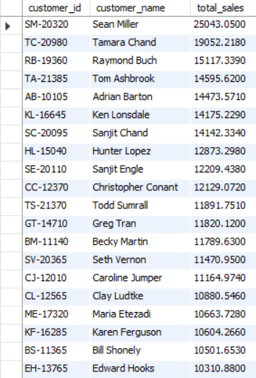

Insight:
The CTE customer_totals aggregates 9,994 line items into 793 per-customer totals, then joins back to the customers table for human-readable names. Sean Miller leads at $25043.05, more than $5,990 ahead of the runner-up — a single customer's enterprise-scale purchase can dominate a top-20 list, which is why mean-based "average customer" metrics are misleading without looking at the distribution.

2. Customers Whose Total Sales Are Above Average (CTE + Subquery)
SQL Query:
WITH customer_totals AS (
SELECT customer_id, SUM(sales) AS total_sales
FROM orders
GROUP BY customer_id
)
SELECT c.customer_name, ct.total_sales
FROM customer_totals AS ct
JOIN customers AS c ON c.customer_id = ct.customer_id
WHERE ct.total_sales > (SELECT AVG(total_sales) FROM customer_totals)
ORDER BY ct.total_sales ASC
LIMIT 20;

Output:
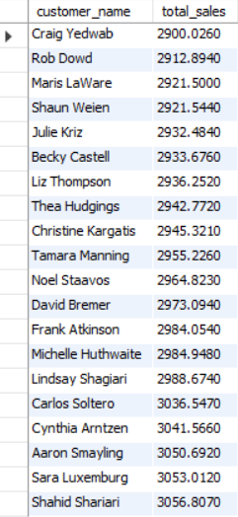

Insight:
The average per-customer total is $2896.85, and 294 of 793 customers (~37.1%) exceed it.
The fact that less than 40% of customers are "above average" is the Pareto principle showing up clearly: a minority of customers drives the majority of revenue, and any retention strategy should weight these accounts heavily.

Section 6: Window Functions
Window functions compute values across a set of rows related to the current row, without collapsing the result set the way GROUP BY does. RANK, DENSE_RANK, and ROW_NUMBER are the most common ranking variants; PARTITION BY restarts the calculation within each group.

1. Rank All Customers by Total Sales (RANK vs DENSE_RANK)
SQL Query:
SELECT c.customer_name,
SUM(o.sales) AS total_sales,
RANK() OVER (ORDER BY SUM(o.sales) DESC) AS customer_sales_rank,
DENSE_RANK() OVER (ORDER BY SUM(o.sales) DESC) AS customer_dense_rank
FROM orders AS o
JOIN customers AS c ON c.customer_id = o.customer_id
GROUP BY c.customer_id, c.customer_name
ORDER BY customer_sales_rank
LIMIT 20;

Output:
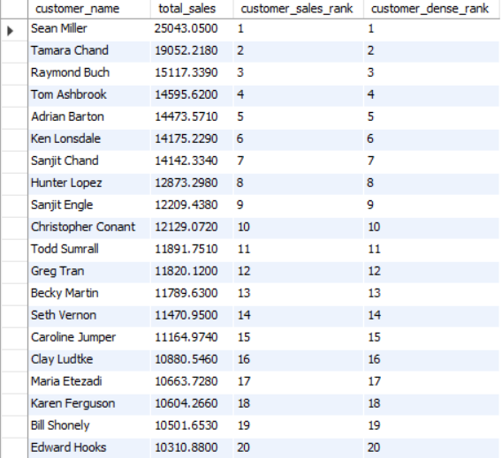
Insight:
RANK and DENSE_RANK differ only on ties: RANK leaves gaps (1, 2, 2, 4), DENSE_RANK doesn't (1, 2, 2, 3). In this dataset the top 10 customer totals are all distinct, so both columns agree — but using both side-by-side is the right defensive habit when ties are possible. Showing both also makes the difference between the two ranking semantics immediately visible to anyone reviewing the report.

2. Assign Row Numbers Within Each Customer (PARTITION BY)
SQL Query:
SELECT customer_id, order_id, product_id, sales,
ROW_NUMBER() OVER (PARTITION BY customer_id ORDER BY sales DESC) AS row_no
FROM orders
ORDER BY customer_id, row_no
LIMIT 20;

Output:
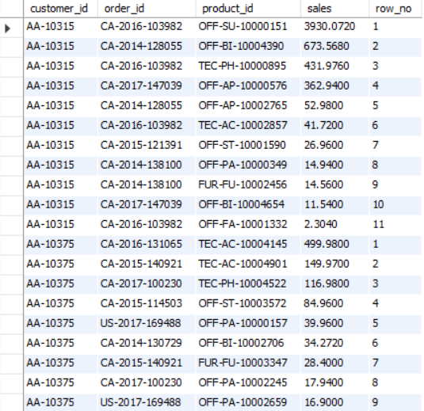

Insight:
PARTITION BY customer_id restarts the ROW_NUMBER counter for every customer, and ORDER BY sales DESC puts each customer's largest line item at row_no = 1.
ROW_NUMBER is preferable to RANK when you need exactly one row per group, since it breaks ties arbitrarily instead of returning duplicates.

3. Top 3 Customers by Total Sales
SQL Query:
WITH ranked AS (
SELECT c.customer_name,
SUM(o.sales) AS total_sales,
RANK() OVER (ORDER BY SUM(o.sales) DESC) AS rnk
FROM orders AS o
JOIN customers AS c ON c.customer_id = o.customer_id
GROUP BY c.customer_id, c.customer_name
)
SELECT customer_name, total_sales, rnk
FROM ranked
WHERE rnk <= 3;

Output:
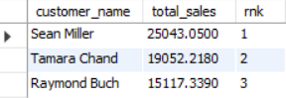

Insight:
Using RANK() with WHERE rnk <= 3 is the correct "top N" pattern when ties matter — if two customers tied for 3rd, both would appear (you'd get 4 rows).
A plain LIMIT 3 would silently drop one of the tied customers. For this dataset there are no ties in the top 3, so the result is the expected three rows; Sean Miller, Tamara Chand, and Raymond Buch together account for roughly $59,200, more than 2.5% of the dataset's total revenue.

Section 7: Final Combined Query (JOIN + CTE + Window)
A single deliverable query that exercises all three advanced techniques: a CTE for the customer totals, a JOIN to attach customer metadata, and two window functions to rank customers both overall and within their segment.

1. Customer Name, Total Sales, Overall Rank & Segment Rank
SQL Query:
WITH customer_totals AS (
SELECT customer_id, SUM(sales) AS total_sales
FROM orders
GROUP BY customer_id
)
SELECT c.customer_id,
c.customer_name,
c.segment,
ct.total_sales,
RANK() OVER (ORDER BY ct.total_sales DESC) AS overall_rank,
RANK() OVER (PARTITION BY c.segment ORDER BY ct.total_sales DESC) AS rank_in_segment
FROM customer_totals AS ct
JOIN customers AS c ON c.customer_id = ct.customer_id
ORDER BY ct.total_sales DESC
LIMIT 20;

Output:
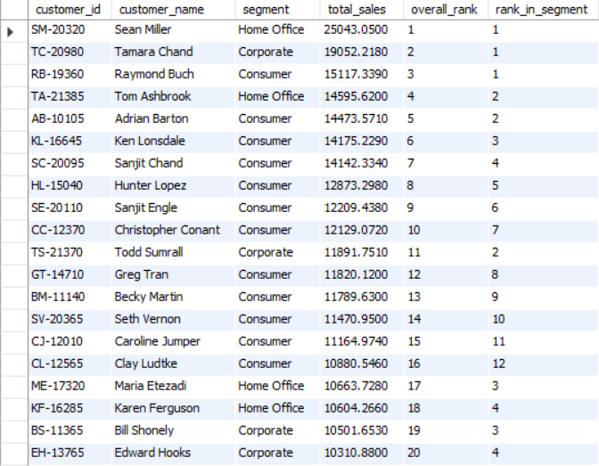

Insight:
Two RANK() windows on the same query -- one global, one partitioned by segment — produce a powerful two-dimensional view: a customer can be #5 overall but #1 in the Home Office segment, exposing where competitive battles are won segment-by-segment.
The Consumer segment dominates the absolute leaderboard because it has the largest customer base, but the Corporate and Home Office segments still produce their own top performers worth a dedicated retention strategy.

Section 8: Business Queries
Business-facing questions answered directly from the analytical model — useful for executive dashboards, retention strategy, and identifying revenue concentration risk.

1. Top 5 Customers by Total Sales
SQL Query:
WITH customer_totals AS (
SELECT customer_id, SUM(sales) AS total_sales
FROM orders
GROUP BY customer_id
)
SELECT c.customer_id, c.customer_name, ct.total_sales
FROM customer_totals AS ct
JOIN customers AS c ON c.customer_id = ct.customer_id
ORDER BY ct.total_sales DESC
LIMIT 5;

Output:
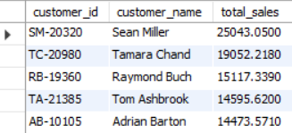

Insight:
The top 5 customers collectively represent roughly $88,300 in lifetime revenue -- about 3.8% of the dataset's total. These are the accounts to protect: dedicated account management, white-glove service, and proactive renewal outreach. Losing even one of these names would materially dent annual revenue, so identifying them early is a baseline retention discipline.

2. Bottom 5 Customers by Total Sales
SQL Query:
WITH customer_totals AS (
SELECT customer_id, SUM(sales) AS total_sales
FROM orders
GROUP BY customer_id
)
SELECT c.customer_id, c.customer_name, ct.total_sales
FROM customer_totals AS ct
JOIN customers AS c ON c.customer_id = ct.customer_id
ORDER BY ct.total_sales ASC
LIMIT 5;

Output:
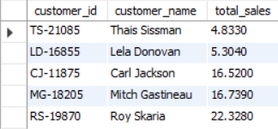

Insight:
All five bottom customers spent under $25 lifetime-- almost certainly one-time buyers who ordered a small accessory and never returned. They are candidates for a low-cost win-back email campaign, or accepted as incidental traffic with minimal lifetime value. Either way, the cost of marketing to them should be calibrated against their realistic spend ceiling.

3. Customers Who Placed Only One Order
SQL Query:
SELECT c.customer_id, c.customer_name,
COUNT(DISTINCT o.order_id) AS orders_placed,
SUM(o.sales) AS total_sales
FROM customers AS c
JOIN orders AS o ON o.customer_id = c.customer_id
GROUP BY c.customer_id, c.customer_name
HAVING COUNT(DISTINCT o.order_id) = 1
ORDER BY total_sales DESC;

Output:
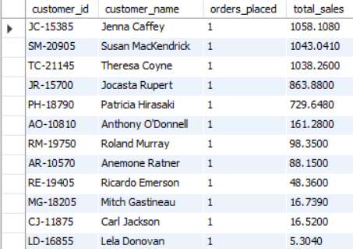

Insight:
Only 12 of 793 customers (~1.5%) placed exactly one order — an excellent retention signal. The Superstore's repeat-purchase rate is genuinely strong. However, Jenna Caffey's single order was worth over $1,000, which is unusual for a one-and-done buyer; she's worth a targeted follow-up to understand what blocked the next purchase.

4. Customers With Above-Average Total Sales
SQL Query:
WITH customer_totals AS (
SELECT customer_id, SUM(sales) AS total_sales
FROM orders
GROUP BY customer_id
)
SELECT c.customer_id, c.customer_name, ct.total_sales
FROM customer_totals AS ct
JOIN customers AS c ON c.customer_id = ct.customer_id
WHERE ct.total_sales > (SELECT AVG(total_sales) FROM customer_totals)
ORDER BY ct.total_sales DESC
LIMIT 20;
Output:
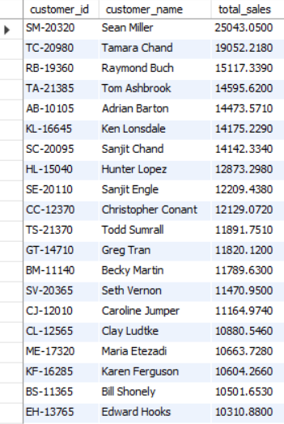

Insight:
294 of 793 customers (~37.1%) sit above the $2,896 customer-average. This Pareto-style skew is the headline finding of the analysis: a minority of customers (~37%) generates the bulk of revenue. Top 20 shown here; the full result returns 294 rows. Sales, marketing, and retention budgets should be allocated proportionally -- disproportionate investment in this above-average tier returns higher ROI than broad-spectrum campaigns.

5. Highest Order Value Per Customer
SQL Query:
WITH order_values AS (
SELECT customer_id, order_id, SUM(sales) AS order_value
FROM orders
GROUP BY customer_id, order_id
),
ranked AS (
SELECT customer_id, order_id, order_value,
ROW_NUMBER() OVER (PARTITION BY customer_id ORDER BY order_value DESC) AS rn
FROM order_values
)
SELECT c.customer_name, r.order_id, r.order_value
FROM ranked AS r
JOIN customers AS c ON c.customer_id = r.customer_id
WHERE r.rn = 1
ORDER BY r.order_value DESC
LIMIT 20;

Output:
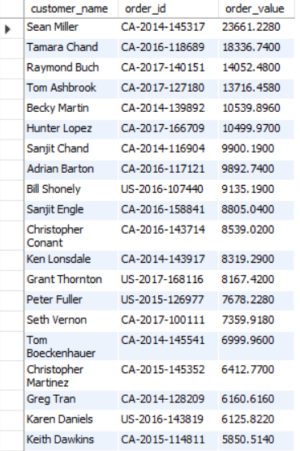

Insight:
"order_value" here is the sum of all line items sharing an order_id -- a more meaningful business metric than "largest single line item" because real Superstore orders typically bundle multiple products.
Sean Miller's CA-2014-145317 at $23,661 is the single largest order in the entire dataset.
ROW_NUMBER() with rn = 1 gives exactly one row per customer; this same pattern (CTE + window + filter on rn = 1) generalizes to any "top-per-group" requirement.

Summary of Key Insights
Five takeaways from the analysis:
- Designed a normalized database schema by separating the raw Superstore dataset into Customers, Products, and Orders tables and maintained relationships using foreign keys.
- Used subqueries to perform advanced filtering and analysis, such as:
- Identifying orders with sales above the average sales value.
- Finding the highest sales order for each customer.
- Retrieving customers whose total sales exceeded the average customer sales.
- Applied Common Table Expressions (CTEs) to simplify complex queries and improve readability by creating intermediate result sets.
- Leveraged window functions (ROW_NUMBER(), RANK(), and DENSE_RANK()) to:
- Rank customers based on total sales.
- Generate segment-wise rankings.
- Identify the highest-value order for each customer.
- Assign row numbers within customer partitions.
- Performed customer analytics by:
- Identifying top and bottom customers based on total sales.
- Detecting customers who placed only one order.
- Comparing customer performance against average sales metrics.
- Gained practical experience in combining aggregations, joins, subqueries, CTEs, and window functions to solve real-world analytical problems commonly encountered in Data Engineering and Business Intelligence.

